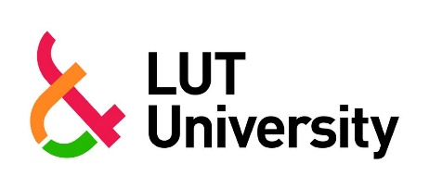

COOPERATION PROGRAMMES WITH PARTNER UNIVERSITIES

CHEMICAL ENGINEERING
- The Erasmus Mundus Master's Programme Sustainable Biomass and Bioproducts Engineering
LUT website for the programme
The official website for the programme

SOFTWARE ENGINEERING

- The Double Degree Nordic Master's Programme in Sustainable ICT Solutions of Tomorrow
LUT website for the programme
The official website for the programme

- The Erasmus Mundus Master's Programme Software Engineers for Green Deal
LUT website for the programme
The official website for the programme

